Technology In Claims

Need For Automation of Claims:

Historically, claims departments have been very reluctant to adopt technology solutions. Claims personnel have seen their jobs as more art than science. The claims adjusting process is laden with nuances and subtleties, and the perception of the job of adjuster as an art has prevented claims management from accepting technology as a way to improve results.

- Manual Decision Making – Lack of Automation :

- Claims management has traditionally perceived technology as incapable of duplicating the decision of an experienced claims adjuster. It was assumed or feared that handing claims processes over to technology would allow fraud to slip by undetected and would result in over- and underpayment of claims, incomplete information due to a lack of questioning, and myriad other potential procedural deficiencies.

- Another factor complicating and inhibiting technology acceptance by claims departments is the strong conviction that claims adjusting is a "people business." The commitment to a one-on-one, person-to-person business process drives claims operations to accept no less than true excellence in claims performance.

- However, the focus on people historically has led claims management to perceive technology as a barrier between the consumer and the adjuster that would cause the customer to feel disconnected and alienated from the carrier.

- The new claims business imperatives that leading claims organizations have identified as
the drivers of superior performance cannot meet expectations without predictive analytics. It is not enough to say that an organization is going to focus on vendor management, management of reserves, and compliance, for example. The human involvement in these management processes demands support in some fashion. The sophisticated predictive capabilities of analytics in conjunction with rules engines are the answer.

- A rules engine is clearly needed to manage critical touch points efficiently and effectively. Likewise, a rules engine can drive an automated correspondence process. However, predictive analytics facilitate a dynamic process as information is gathered. Claims expand and contract in scope as information is obtained, and predictive analytics can adjust the automated responses accordingly. Through use of predictive analytics, much of the life cycle of a claim can be managed in an automated fashion and human resources brought in only when required.

- Work Flow Management :

- Traditional claims workflow involved multiple manual handoffs to various levels of claims workers. The process was inefficient and required weeks or months to complete claims settlements, even for relatively uncomplicated losses. Claim files were paper documents, and no one could complete a task until the physical claim file was obtained. Passing claim files from one worker to the next was the genesis of a good percentage of the time delays. Information gathering was done by mail, with correspondence going in both directions. All of these procedures and processes added a lot of time to the settlement process.

- Research reveals a new vision for claims workflow. straight-through STP. To meet consumers' demand for a seamless customer service experience, a carrier should deliver
certain types of services with no human intervention, in a straight-through processing fashion. Examples are auto glass replacement services and towing services. A potential scenario could entail automatically locating of service providers near the customer in real time during the initial contact and electronically pushing authorization directly to a service provider.

- Regulation and Compliance :

- The regulatory and compliance burden put upon claims operations has historically been extraordinary. This burden is not lessening. The insurer must make certain that appropriate forms are delivered, state-mandated service time frames are met, and mandatory information is provided to the consumer. Performing this Herculean task manually is clearly out of the question, and new methods of management are required.

- Predictive analytics standardizes response and practices by eliminating human error and ensures that data is treated in uniform, unbiased manner. This facilitates both compliance and reporting. The use of BI and predictive analytics is discussed in the later part of this article.

- Reserve Management :

- The degree to which carriers successfully manage claims reserves measurably drives profit and loss. Determining how much to reserve for a claim is where art and science truly merge in the claims process. While setting reserves is done at the actuarial level, in complex claims cases reserves are generally set by an adjuster utilizing years of earned expertise. Again, with the increased workload burden facing most claims organizations, this important task can be imperiled unless the carrier brings new tactics to the process.

- Predictive analytics can assess the subtle changes in claims details and set the appropriate reserve.

- Vendor Management :

Carriers have complex networks of preferred service providers, and managing them can be highly labor intensive. Vast quantities of bills from service providers flow through carriers every day. Without laboriously going over each and every one, it is very difficult to identify irregularities or abnormalities. Predictive analytics can assess electronic invoices and find charges and trends that are outside the norm for providers in the same
geographic area. Or the predictive model can identify relationships between service providers. For instance, if a certain medical provider shows up on a regular basis, aligned with the same legal professional, and their billable charges are significantly higher than others in that area, the system would automatically flag the transactions
for attention.

- Litigation Management :

As with vendor performance management, where the volume of bills and invoices can be staggering, predictive analytics can assess legal charges and identify those that are outside the norm for a certain geographic area or a certain type of claim. Additionally, models can identify claims that have a probability for litigation so that they can be rigorously monitored.
Two events changed the landscape of claims operations and caused claims departments to move rapidly along the path toward adoption of technology.

Human-Caused Disaster Results in an Atmosphere of Change

- The first event that led to a more favorable view of technology was the aftermath of the tragic events of September 11, 2001, in particular the destruction of the twin towers in the financial district of New York City.

- An extraordinary number of businesses were dislocated by the destruction of the World Trade Center and the surrounding buildings. Many paper-based businesses found themselves in an exceptionally difficult position because all their work documents were destroyed. To keep business operations functioning, employees were relocated to other company sites or to their personal home offices.

- Paper-based companies found this solution to be very difficult and unsatisfactory, not only because they were missing the information that was lost when their documents were destroyed but also because reallocating paper to disparate locations was not an efficient option.

It became apparent to carriers' claims management that utilizing technology to ensure ongoing business operations in the face of business interruption, for whatever reason, was critical. This was the first step toward a more automated claims environment.

Compliance Forces Technology Adoption

- The second force for some automation of claims operations was the Sarbanes-Oxley Act of 2002 (SOX). The requirements specified by SOX were impossible to fulfill with a paper-based business process. In no case could a carrier manually aggregate and report on the overwhelming amount of financial data contained in claims departments' paper files.

- Claims management added this compelling development to the urgent need for technology to support ongoing business operations, and many buying decisions for claims automation ensued. Numerous carriers made technology purchases strictly for compliance and operational purposes. Research reveals that a significant number of those carriers are now buying replacement claims systems because today's Marketplace pressures are mandating functionality that cannot be met with current incumbent systems.

Technology in Claims: Core Claims Systems
A core claims system is the transaction and record system that covers the life cycle of each claim and interacts with internal and external applications and data sources. A modern core claims system provides the following essential functionality for an adjuster and claims manager:

- FNOL (first notice of loss), recording the first report of a claim and verifying existing policies and coverages
- Assignment of a claim to one or more adjusters
- Adjuster’s desktop or workstation, a set of screens providing easy access to information, images, tasks, and diaries (notes) related to an adjuster’s assignment claims
- Document or content management: an ability to create, use, and store documents, correspondences, and information
- Reserving: setting and revising loss and expense reserves
- Subrogation and salvage: the capacity to identify and press claims against responsible third parties; and the ability to track efforts to obtain value for damaged property
- Customization and configuration for products, processes, and decisions: achieved through configuration tools, workflow or business process management capabilities, and rules engines
- Integration with an insurer’s internal systems and databases; and with external customers, partners, and processes (such as estimation applications, repair shops, medical providers, attorneys, etc.)

Some core claims systems include more than these elements, incorporating portals for claimants or agents, medical bill review, or litigation management. A good core system also provides several ways to integrate these and many other functions from many independent software vendors (ISVs) that an insurer may choose.

Figure shows the full spectrum of claims solutions available to insurers. Core claims systems occupy the center of this spectrum. They are surrounded by an inner ring of enterprise applications and integration methods—enterprise content management (ECM), business process management (BPM), business rules engines (BRE), and service-oriented architecture (SOA). In the outer ring of the spectrum are various claims tools, for example capability to report first notice of loss (FNOL) such provided by First Notice Systems, front-end adjuster’s desktop as provided by i-Flex’s ClaimsPath, estimation tools as provided by CCC Pathways, etc.

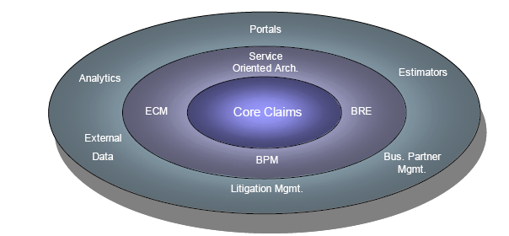

Business drivers to replace legacy claims systems:

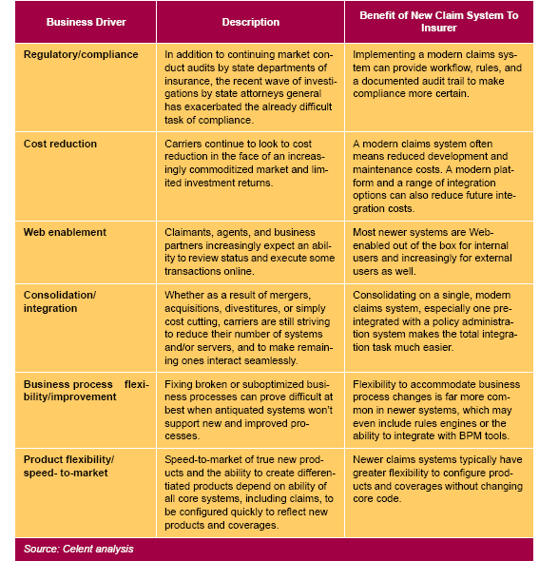

Vender View: Claims Systems 2006

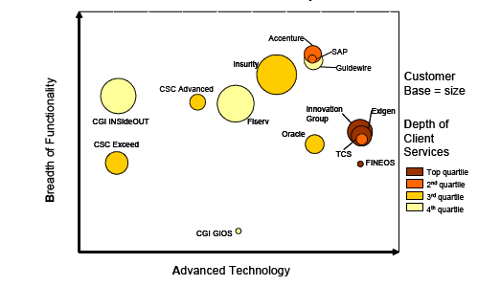

- The ABCD Vendor View positions each solution in a single X/Y scale, with the horizontal
axis displaying the relative level of advanced technology and technical flexibility and the vertical axis displaying the relative breadth of functionality. As noted above, the “advanced technology” category also includes the level of flexibility and options each system offers for platforms, databases, and integration options.

- The size of the system’s customer base is represented by the size of the bubble, while depth of client services is represented by color density. For size and depth, the vendors are divided into quartiles based on their relative position. All the vendors were graded on the same scale, regardless of their target market segment. Quartiles were determined by relative position to the highest scorer.

- The ABCD Vendor View is intended to provide an easy to understand view of a complex vendor marketplace. Unlike a simple “four-quadrant” map, solutions in the upper right are not necessarily the best solutions—in an area as complex and idiosyncratic as claims, there is no one “best” for all cases. Insurers should consider which factors in breadth, technology, experience, and client service are most important to them, and use the profiles and comparative tables in this report to generate their own short lists

Technology in Claims: Claim Estimation Solutions

Claim estimation solutions document the physical aspects of losses–and develop an estimate for the costs of repairing, restoring, replacing, and settling claims for such losses. They play an important role in making the adjustment process fast, accurate, consistent, and fair.

We will look at three categories of loss estimation solutions: automobile physical damage, property and bodily injury.

- Automobile physical damage estimation solutions are used by an insurance company, a repair shop, or a field adjuster to determine the cost of repairing a policyholder’s damaged automobile or replacing it in the case of a total loss.
- Property estimation solutions are similarly used by an insurance company, a restoration contractor, or a field adjuster to identify the cost of repairing or replacing residential or commercial property and contents that have been damaged by fire or other covered perils.
- Bodily injury estimation solutions are primarily used when an insurance company’s policyholder is involved in an automobile accident in which a third party is injured and asserts that the policyholder is liable for the costs of medical treatment, rehabilitation, and general damages (pain and suffering).

Estimation Solution: Components:

Automobile physical damage and property estimation solutions are primarily used by field adjusters, who physically inspect a damaged car or building in order to estimate the cost of repairing, restoring, or replacing it. Field adjusters may be insurance company employees or independent contractors. A complete automobile physical damage or a property estimation solution has the eight components shown in Figure below: the estimation application itself; databases for parts, labor, contents (property losses only), replacement cost, and completed estimates, a workflow management application, and a reporting and analytic component.
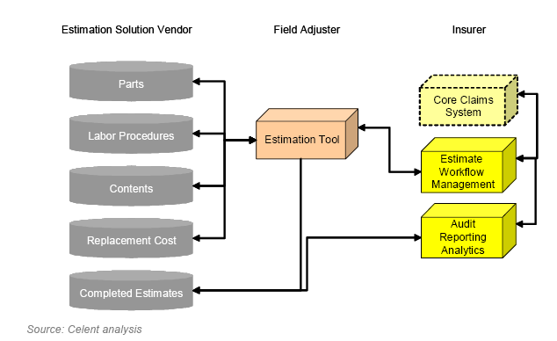

- The estimation tool is used primarily in the field by a field adjuster. It is often also used by auto repair shops, restoration contractors, and insurer desk adjusters. It provides graphic or text-based access to very large parts and labor procedure databases maintained by the estimation solution vendor. The field adjuster selects the appropriate parts and labor procedures, and the tool calculates the cost.

- For losses of personal property (furniture, electronics, etc.) within a damaged building, the estimation tool accesses a very large content database and gives the cost of providing similar items to the claimant.

- An insurer also has to know if the cost of repairing or restoring the vehicle or building exceeds the cost of replacing it. For this purpose the estimation tool accesses another large database and calculation engine for replacement costs.

- Completed estimates are sent to the insurer, and also to a large database maintained by the vendor with estimates from many adjusters and insurers for many years.

- The insurance company has an estimate workflow component that allows it to assign estimates to field adjusters and monitor their progress.

- Another component (or components) gives an insurer the ability to audit estimates for compliance with its guidelines (e.g., new vs. replacement parts), to create reports, and perform analytics on both its own and industry estimating activities–using information from the completed estimates database and other sources.

- Information and data from the insurer’s estimate workflow and audit/reporting/ analytics components will be exchanged with the insurer’s core claims system (which is not part of an estimation solution per se).

A bodily injury estimation solution has a broadly similar set of components, but the types of databases (e.g. anatomical, collision patterns, etc.) and the recommendations produced (credibility of an injury, range for general damages settlement) are quite different.

Technology in Claims: Claims Analytics - Using Predictive Modeling and BI to enhance P&C insurance claims

The Need for Claims Analytics:

During the past five years, P&C insurers have focused on core operational systems, such as policy administration and claims management, rather than assessing their data and BI needs in business units outside of the actuarial department. This is slowly changing as Tier 1 and Tier 2 companies develop comprehensive strategies aimed at improving claims delivery and processing and reducing losses. As part of this effort, P&C insurers need a new way to analyze and present claims data and models to claims managers. This is to help assess claims performance, the cost of claims handling, and the impact of claims handling on customer satisfaction and retention and other business objectives, as well as to perform predictive modeling to assess claims reserve needs. The new tools needed to support these tasks are called "claims analytics."

Definition of Claims Analytics:

Claims Analytics is the use of business intelligence, reporting solutions, dashboards, data mining and predictive modeling technologies to improve, manage, and analyze claims data and performance. Overall, three components make up claims analytics: claims analysis, reporting and predictive modeling (see Table below)

Claims Analytics Components:

Claims Analytics Component | Description
Claims Analysis | This includes analytics for reporting (such as standardized KPIs and performance data) and complex analytics that utilize modeling, including predictive tools, ad hoc analysis and statistical modeling. Operational analytics for performance assessment are key (for example, counting process claims or pending claims). However, the maximum value of claims analytics resides in analyzing trends that are correlated with business outcomes, such as customer satisfaction in the claims experience, fraud losses and reduced litigation costs.
Reporting | Commonly, claims managers and professionals will need prebuilt reports highlighting the outcome of analysis to identify claims bottlenecks, performance problems or high-risk areas. Reporting is also needed ad hoc or on demand (for example, catastrophe assessment and reporting). This is the output for analytics.
Predictive Modeling | Predictive analytics (that is, analytics that give the business user the power to run scenarios and projections of future outcomes) is the most powerful form of claims analytics and the most untapped tool in the industry. Most claims analytics projects today are targeted at the use of tools to enhance the analysis of past performance, current-day production levels and performance — that is, operational analytics.

Basics of Claims Analytics:

Claims analytics provide insurers a way to use BI and predictive modeling within the claims department. This empowers business users with the much needed information to drive company success, including driving customer loyalty, reducing operational costs in the claims department and improving the ability to manage claims losses, as well as fraud identification. Key to this is performance reporting, including performance assessment, cost, reserve, claims experience over time (that is, aging claims), recovery, overview of a business based on region and zone, open fraud cases by adjuster, and litigation summaries. Claims analytics tools should have the following abilities:

- Mine the data (scheduled and ad hoc). Normal results, such as those listed below for reports, will be run at scheduled intervals; however, additional reports may be required in real time, such as fraud detection, recovery identification or utilization/resource forecasting. Many of these solutions, such as fraud detection, are present in the market, but they lack the full line of business support (for example, supporting workers' compensation, specialty lines, and commercial and personal lines in a single solution) and proven implementations.

- Report on the results, such as closed claims, pending claims, claims by adjuster and geography, adjuster workload, exposure management, account loss experience, catastrophe reporting, claims financials (for example, the average cost of a claim), and pending financials. Current-day reporting, as well as comparison with other months and the past year, is also commonly performed.

- Present the results in dashboards for claims managers and adjusters, as well as other business users, such as underwriters, actuaries and the finance department.

Claims analytics solutions should come with off-the-shelf models (for example, fraud scoring models), but they should also enable claims professionals to easily build new models based on their product line, strategy or need. User interfaces should be targeted at the business user who is not trained in statistical reporting or event BI, but who has an overarching business performance question and needs to analyze this.

Solutions should also have the ability to mine structured and unstructured data. Most solutions focus solely on structured data, but a massive amount of claims data in files are in an unstructured format. Content, including those in claims or adjuster files, is important content that must be included in analysis, and solutions should encompass both structured and unstructured data capabilities.

Overall, the use of claims analytics solutions provide multiple benefits for P&C insurers, including the ability to respond faster to customers when claims occur, quickly identify fraudulent claims (early identification versus batch processing), enable "fast track" handling, analyze where the insurer is incurring the greatest risks (that is, regional and customer segmentation risks), and reduce the cost of claims handling.

Claims Analytics Solution Market:

As the interest in claims analytics rises, most P&C insurers find it difficult to find suitable solutions to meet their business needs. The solution market for claims analytics is immature, with various types of solutions that solve part of the problem, but lack complete capabilities. For insurers wanting claims analytics, it is important to note that these solutions can be sold as on-premises software or hosted in software as a service (SaaS) option. Most vendors offer software; however, new market entrants such as Full Capture Solutions and Claim Insights offer a SaaS option for P&C insurers. There are three types of claims analytics vendors: niche solutions, BI solutions and claims management solutions.

Niche Solutions:

Some solutions are niche and focus only on a subsegment of claims analytics. Examples of niche solutions include:
- Fraud detection and identification solutions. Vendors such as SPSS and SAS are building fraud solutions to target this growing problem. These solutions will use predictive techniques for improved fraud identification.

- Activity-based-costing solutions. Other vendors, such as Business Objects (acquired by SAP), are building out an activity-based-costing model for P&C claims. This model builds baseline metrics for insurers and assesses profitability and cost management in the claims department. As a result, insurers can take a deep dive into their claims to assess claims relevance to financial objectives and determine the true cost of a claim.

- Predictive modeling tools for specific lines of business. Other vendors offer insurancespecific predictive modeling tools — for example, Valen offers a tool for commercial P&C and workers' compensation product lines.

- Insurance-specific analysis vendors that offer specialized systems with prebuilt insurance models, reports and dashboards. Several new market entrants with new solutions are targeting this market, including InsFocus and EagleEye Analytics.

BI Solutions:

Vendors such as SAS and SPSS also offer generic BI solutions, which allow the IT department to manually build out claims analytics in-house. Although this will work, it takes more time and investment (not to mention more involvement from the claims business users to identify key functionality, models and needs). These BI vendors have limited insurance domain knowledge, and they are generally unable to help P&C insurers assess claims intelligence, reporting and content needs. They do not have the background or experience to help companies build comprehensive claims models.

Claims Management Solutions:

Traditional claims management vendors have limited to no background in claims analytics. Some vendors are currently trying to build out claims BI solutions — by themselves or via partnerships.
Today, few solutions have much built-out content delivered in the base solution. Vendors such as
SAP that now own BI vendors (such as Business Objects) will begin to more tightly integrate the two solutions to offer P&C insurers more capabilities. However, they will be priced separately, and claims reporting and predictive modeling will not come in the base claims management solution. Other vendors such as Innovation Group have acquired capabilities that they are integrating with their base claims management solution for enhanced claims analysis, including fraud analysis and claims performance reporting.

Claims systems are still transaction-oriented and lack strengths in data management and mining (that is, BI). In addition, most claims systems have "vanilla" or no dashboard capabilities to present data to business users. Ideally, it would be best if buyers had complex and robust embedded claims analytics in their core claims management applications; however, this is unlikely during the next three years based on vendor competencies and R&D plans.

Market Overview:

Today, it is difficult to acquire a package that has full, end-to-end claims analytics. Rather, insurers have options to buy a "slice" of their needed functionality via these three options. Each option has limited functionality, which will require buyers to have clearly defined requirements on what they need in the system and possibly to integrate multiple solutions to build their claims analytics platform. This will require having open technologies, having a consistent data model for claims data, employing a service-oriented architecture (SOA) to help with system interoperability and having stronger vendor relationship management capabilities to manage various relationships.

Furthermore, many of these solutions are in their infancy, having functional gaps, lacking a reference able customer base and dealing only with structured data. Most solutions, for example, are not able to analyze unstructured data, which would be housed in adjuster files. Unstructured data files are often unique and hard to analyze. Solutions for unstructured data assessment utilize more than just BI, but they also use a combination of techniques, such as text mining/analytics, search and categorization technologies, and semantic technologies.

Finally, it is imperative that P&C insurers pair claims analytics with their BPM projects to get optimum business results. There will be projects in which they will be altering claims processes, for instance, and wanting to measure the impact of the change. BPM will help with this, as well as in feeding claims analytics solutions to help identify processing bottlenecks and associated processing complications (especially in high-volume tasks or in catastrophe handling). BPM solutions are an essential part to help claims operations manage and automate workflow. They are also a piece of the underlying claims analytics platform in many cases when P&C insurers lack a modern, workflow-based and rule-based claims management system.

By Savitha Deekonda & Anirban Banerji

Sources:

Celent:
Claim Estimation Solutions: Overview and Solution Spectrum
Core Claims Systems Vendors

Gartner:
Claims Analytics: Using Predictive Modeling and BI to Enhance P&C Insurance Claims

Tower Group:
Technology in US P&C Insurance Claims Operations: Transforming a People Business

